Arrays are really cool

See MDN documentation on array

.length // gives length of array

.push(item) // adds the item to the last

.pop() // returns the item from the last

.unshift( item ) // adds the item at the front of array

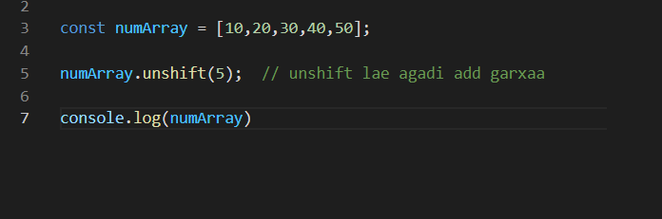

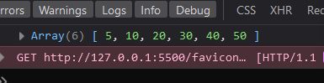

.shift( ) // removes the item from the front

.forEach ( )

runs a callback function to each array item

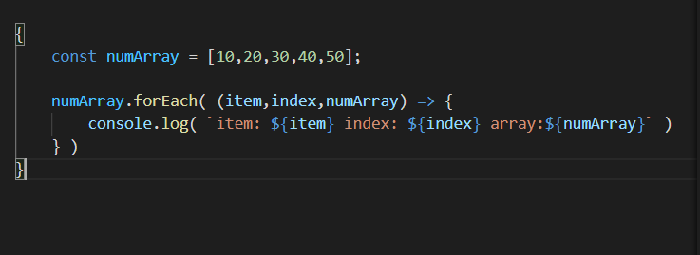

it can take three arguments but all those may not be needed for most of use cases

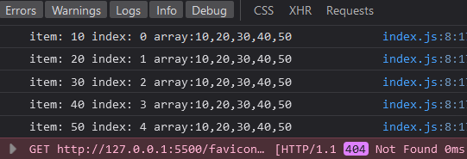

Also in javaScript Array is an object

Those array items, they are just key value pairs

where keys are the index number and values are the items

see

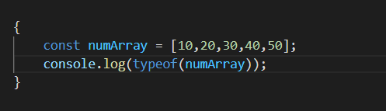

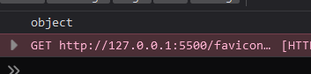

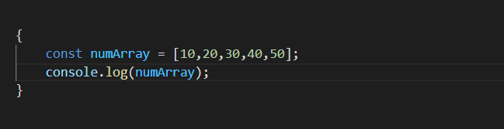

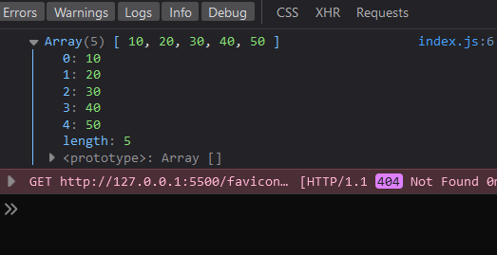

See there are these keys value pairs

Since array is also an object the items are also accessed by this

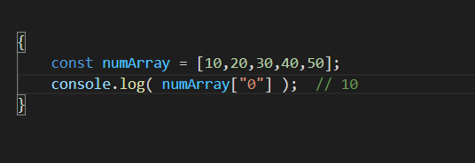

**But Arrays are Special Types of Objects in Java Script**

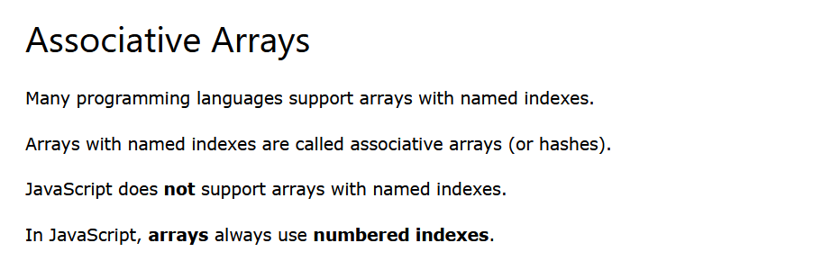

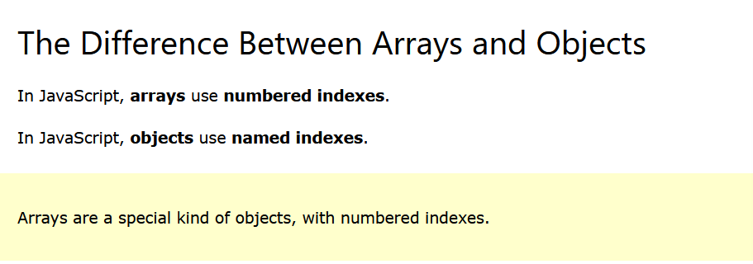

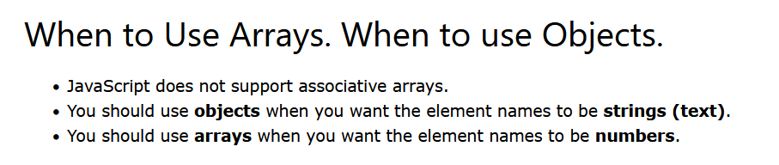

since we cannot use typeof( ) operator to know if the variable is array or not

So ES5 introduced a array method

Array.isArray ( )

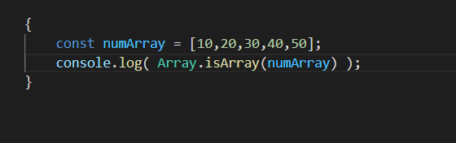

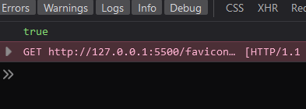

**Looping in array**

Well we can get the length easily by .length property, and we can easily use for( ) loop

But

We have for ( of ) loop

for(item of numArray ) { }

It is just a simpler version of regular for loop